Sql project

Task 1
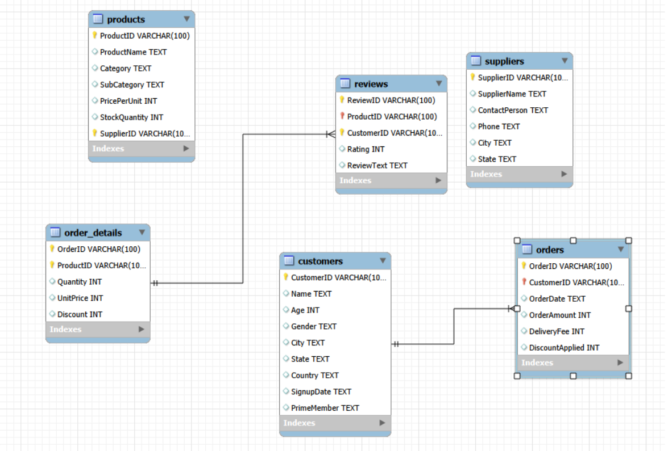

Task 2
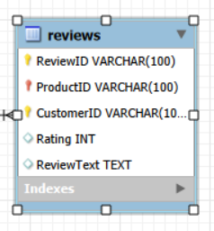

Task 3

○ Retrieve all customers from a specific city.
select * from amazon.customers where city='austinton';

○ Fetch all products under the "Fruits" category.
select ProductName,Category from amazon.products where category='fruits';

Task4

○ CustomerID as the primary key.
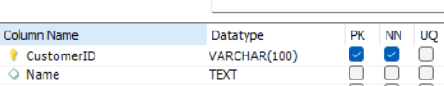

○ Ensure Age cannot be null and must be greater than 18.
alter table amazon.customers
modify age int not null;
alter table amazon.customers
add constraint check ('age'>18);

○ Add a unique constraint for Name.
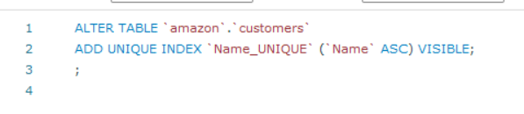

Task5

Insert 3 new rows into the Products table using INSERT statements.
insert into amazon.products (productid,productname,category,subcategory,priceperunit,stockquantity,supplierid) values
('dfghjkui','Ok Snack','Fruits','Sub-Dairy-1',515,654,'rtyujijih'),
('tyfigiuh','Exist Vegetable','Bakery','Sub-Fruits-2',546,646,'ctguihii'),
('guihioj','Local Fruit','Vegetables','Sub-Meat-4',559,846,'busiug');

Task6

Update the stock quantity of a product where ProductID matches a specific ID.
select distinct productid ,StockQuantity from amazon.products order by ProductID;

Task 7

Delete a supplier from the Suppliers table where their city matches a specific value.
delete from amazon.suppliers where city='South Ana';

Task 8

○ Add a CHECK constraint to ensure that ratings in the Reviews table are between 1 and 5.
alter table amazon.reviews add constraint rech check (rating between 1 and 5);

○ Add a DEFAULT constraint for the PrimeMember column in the Customers table (default value: "No").
alter table amazon.customers alter column primemember set default 'no';

Task 9

○ WHERE clause to find orders placed after 2024-01-01.
select * from amazon.orders where orderdate>01-01-2024;

○ HAVING clause to list products with average ratings greater than 4.
select distinct(productid),avg(rating) from amazon.reviews group by productid having avg(rating)>4;

○ GROUP BY and ORDER BY clauses to rank products by total sales.
select rank() over(order by sum(orderamount)desc) as rank_no,orderid,sum(orderamount) as total_sales FROM amazon.orders group by orderid order by total_sales desc;

Task 10

Calculate each customer's total spending.
select customerid,sum(orderamount) as total_spending from amazon.orders group by customerid;

Rank customers based on their spending.
select rank()over(order by sum(orderamount)desc) as rank_no,customerid,sum(orderamount) as total_spending from amazon.orders group by customerid order by total_spending desc;

Identify customers who have spent more than ₹5,000.
select customerid,sum(orderamount) as total_spending from amazon.orders where OrderAmount>5000 group by CustomerID order by total_spending desc;

Task 11

○ Join the Orders and OrderDetails tables to calculate total revenue per order.
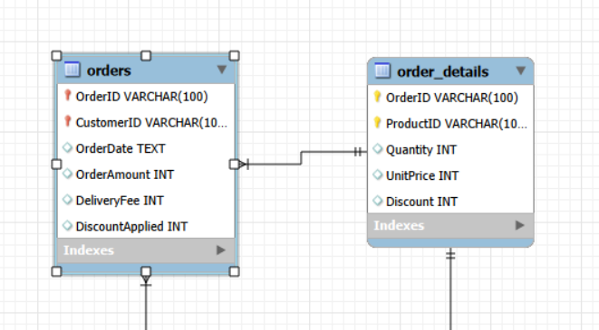

○ Identify customers who placed the most orders in a specific time period.
select distinct (CustomerID), orderid from amazon.orders order by customerid desc limit 1;

○ Find the supplier with the most products in stock.
select StockQuantity,SupplierID from amazon.products order by StockQuantity desc limit 1;

